Web mining Assignment 2

19BCE2311 Gaurav Singh

Question:

**Practice Programming Exercise:**

Write a python program to

* Extract content from two text files attached
* Count the total number of unique terms in each text file (after removing stop words)
  + [List of additional Stop words to be considered = ['.',',','a','they','the','his','so','and','were','from','that','of','in','only','with','to']]
* Apply Stemming and lemmatization separately on the terms present in both files
* Print their number of unique terms after stemming and lemmatization separately.
* Display the result as Term-Document matrix representation using Pandas (use Bag-of-words model)

|  |  |  |  |  |
| --- | --- | --- | --- | --- |
| **List of Terms** | **Stemmed Term** | **Lemmatized Term** | **DOC1 Frequency** | **DOC2 Frequency** |
| Programming | Prog | Program | 10 | 0 |

Screenshots

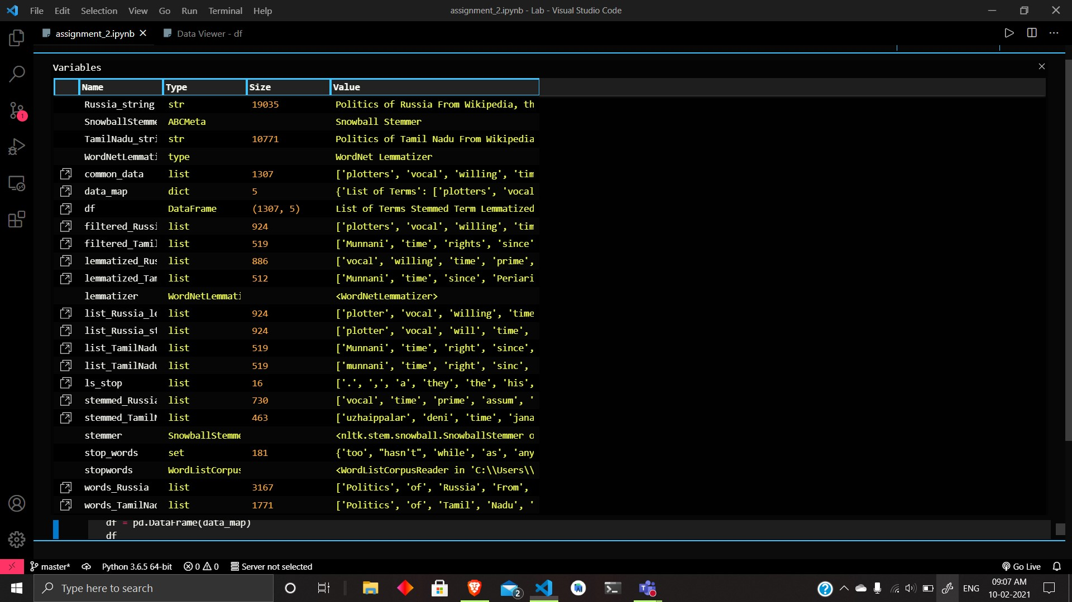

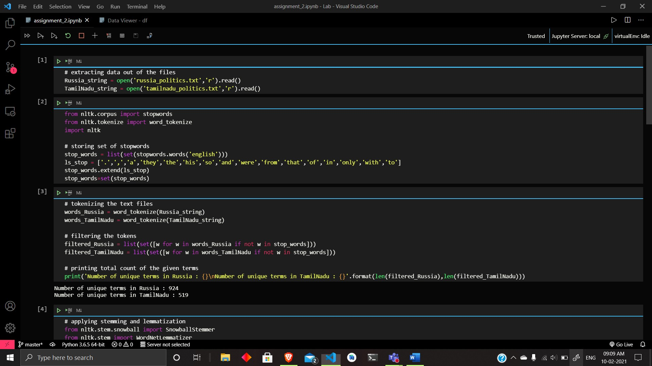

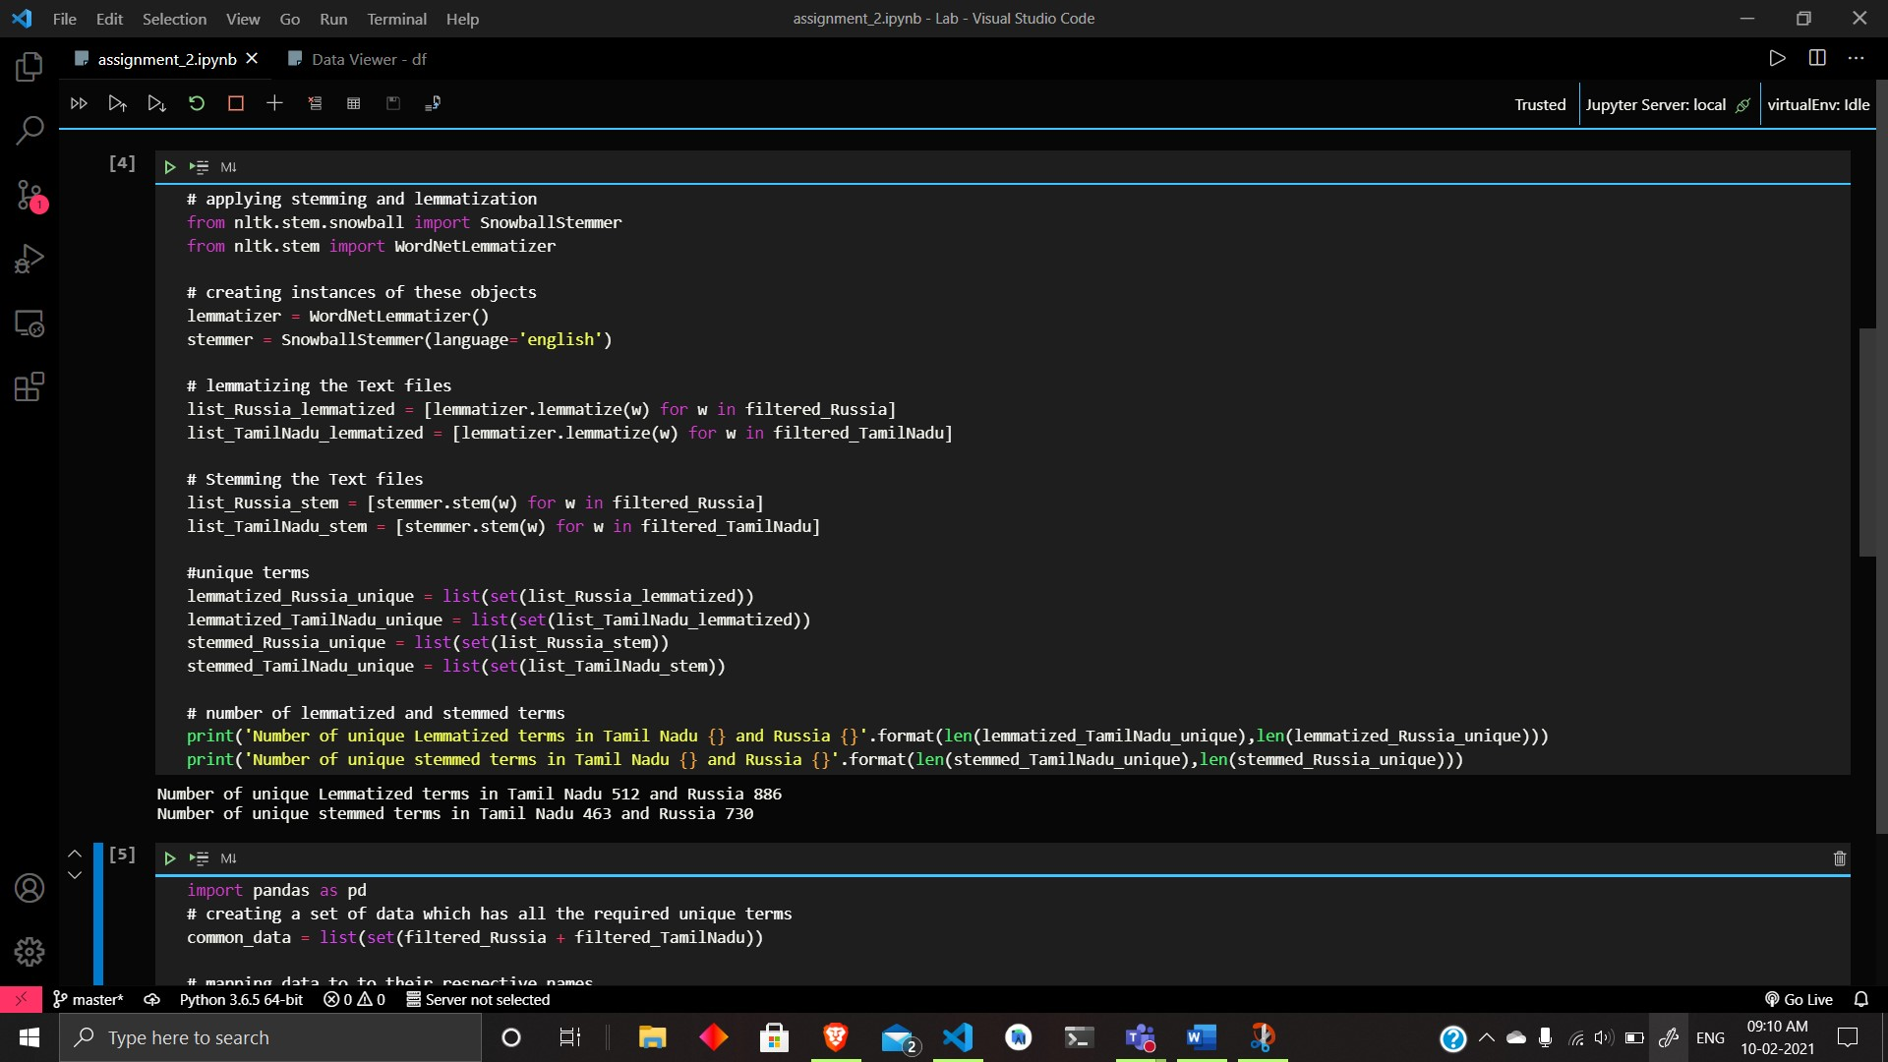

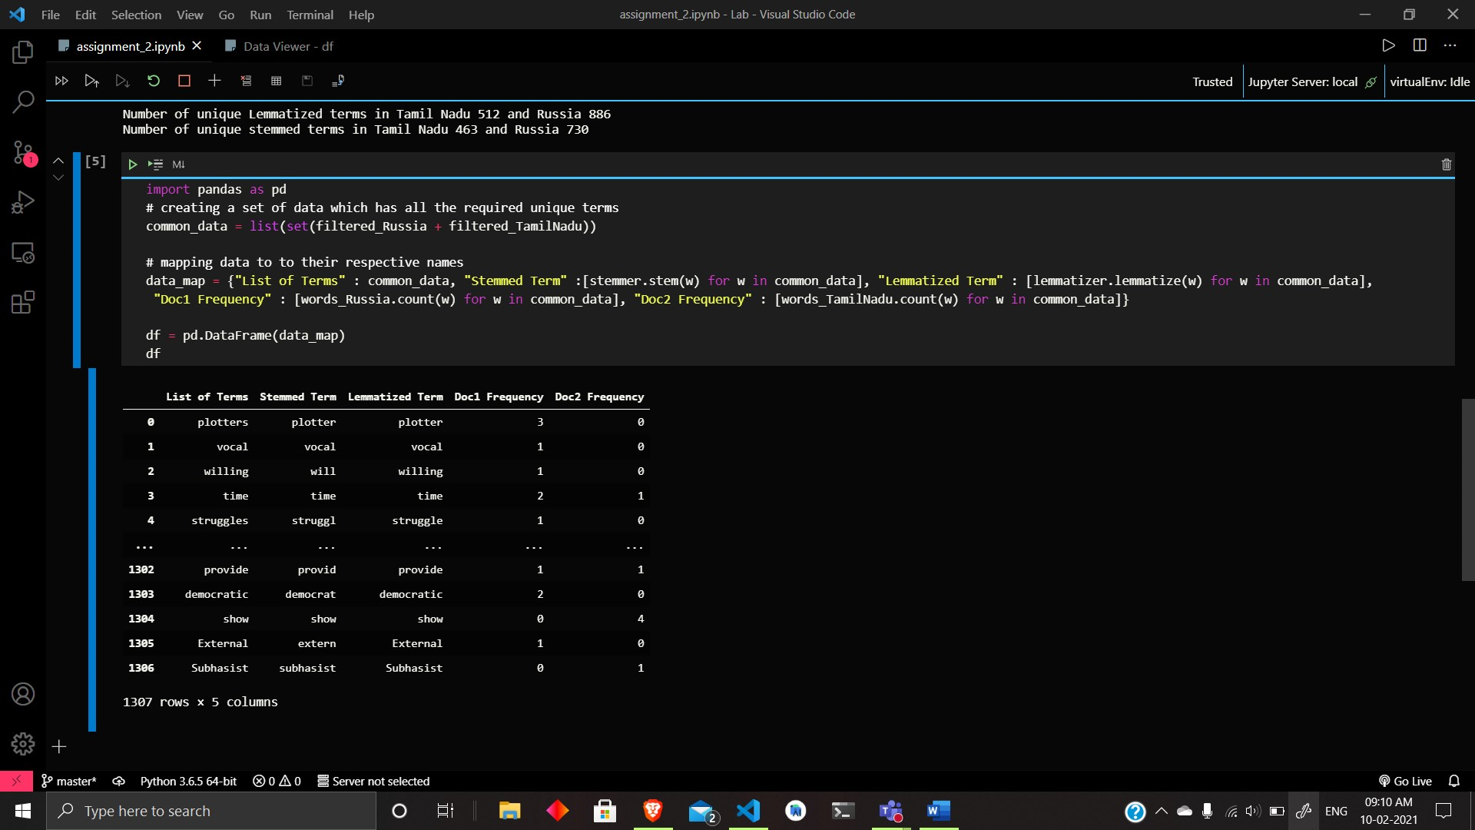

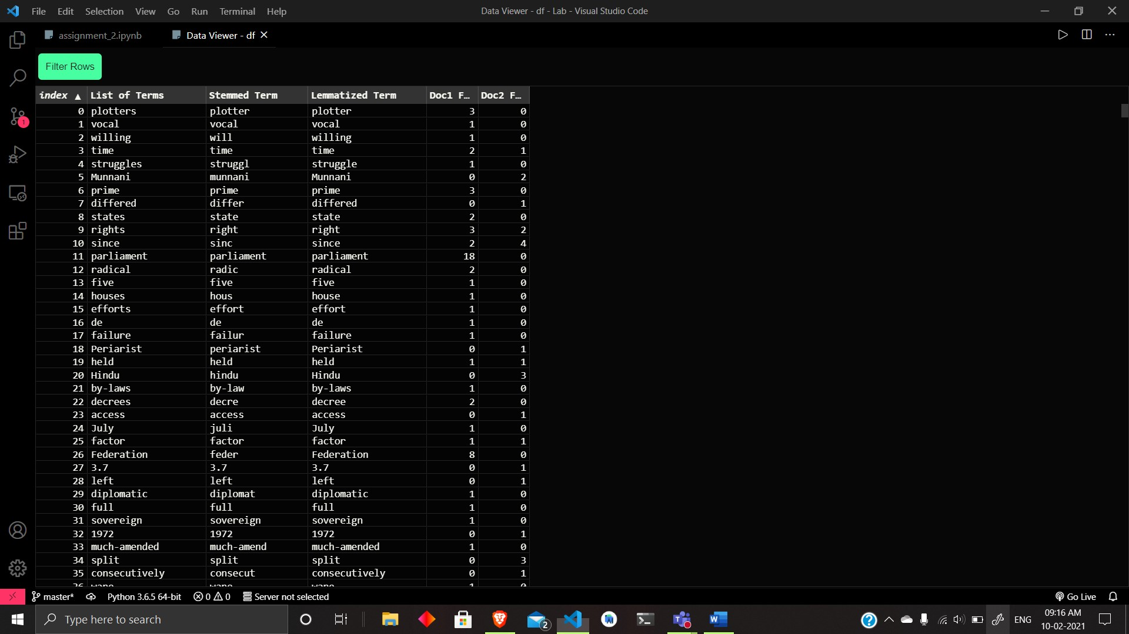

Code:

# extracting data out of the files

Russia_string = open('russia_politics.txt','r').read()

TamilNadu_string = open('tamilnadu_politics.txt','r').read()

from nltk.corpus import stopwords

from nltk.tokenize import word_tokenize

import nltk

# storing set of stopwords

stop_words = list(set(stopwords.words('english')))

ls_stop = ['.',',','a','they','the','his','so','and','were','from','that','of','in','only','with','to']

stop_words.extend(ls_stop)

stop_words=set(stop_words)

# tokenizing the text files

words_Russia = word_tokenize(Russia_string)

words_TamilNadu = word_tokenize(TamilNadu_string)

# filtering the tokens

filtered_Russia = list(set([w for w in words_Russia if not w in stop_words]))

filtered_TamilNadu = list(set([w for w in words_TamilNadu if not w in stop_words]))

# printing total count of the given terms

print('Number of unique terms in Russia : {}\nNumber of unique terms in TamilNadu : {}'.format(len(filtered_Russia),len(filtered_TamilNadu)))

# applying stemming and lemmatization

from nltk.stem.snowball import SnowballStemmer

from nltk.stem import WordNetLemmatizer

# creating instances of these objects

lemmatizer = WordNetLemmatizer()

stemmer = SnowballStemmer(language='english')

# lemmatizing the Text files

list_Russia_lemmatized = [lemmatizer.lemmatize(w) for w in filtered_Russia]

list_TamilNadu_lemmatized = [lemmatizer.lemmatize(w) for w in filtered_TamilNadu]

# Stemming the Text files

list_Russia_stem = [stemmer.stem(w) for w in filtered_Russia]

list_TamilNadu_stem = [stemmer.stem(w) for w in filtered_TamilNadu]

#unique terms

lemmatized_Russia_unique = list(set(list_Russia_lemmatized))

lemmatized_TamilNadu_unique = list(set(list_TamilNadu_lemmatized))

stemmed_Russia_unique = list(set(list_Russia_stem))

stemmed_TamilNadu_unique = list(set(list_TamilNadu_stem))

# number of lemmatized and stemmed terms

print('Number of unique Lemmatized terms in Tamil Nadu {} and Russia {}'.format(len(lemmatized_TamilNadu_unique),len(lemmatized_Russia_unique)))

print('Number of unique stemmed terms in Tamil Nadu {} and Russia {}'.format(len(stemmed_TamilNadu_unique),len(stemmed_Russia_unique)))

import pandas as pd

# creating a set of data which has all the required unique terms

common_data = list(set(filtered_Russia + filtered_TamilNadu))

# mapping data to to their respective names

data_map = {"List of Terms" : common_data, "Stemmed Term" :[stemmer.stem(w) for w in common_data], "Lemmatized Term" : [lemmatizer.lemmatize(w) for w in common_data], "Doc1 Frequency" : [words_Russia.count(w) for w in common_data], "Doc2 Frequency" : [words_TamilNadu.count(w) for w in common_data]}

df = pd.DataFrame(data_map)

df